


Overseer’s Desk

As we draw ever so close to the end of another year may we indeed remain steadfast immoveable and be found always abounding in the work of the Lord. This admonition comes to us from the precious heart of Paul a true apostle of Jesus Christ. He is also very careful to point out “that our labor is not in vain in the Lord,” 1 Cor. 15:58. May every sainted believer continue to be true and faithful until the end!
How blessed we are to come to another Thanksgiving quickly followed by the Yuletide season of celebrating the incarnation of our divine Lord and Savior. May we not forget that Thanksgiving is not so much a day or a season but a lifestyle.
As we joyously celebrate with family and friends may we never forget the poor, the oppressed, the marginalized and the less fortunate among us and all around. Let’s embrace the refugees seeking a better way of life as we all desire and let us remember to be kind to strangers as the Word admonishes – Hebrews 13:2. Blessed and wonderful Thanksgiving to one and all!
Leadership Conference 2015
The Leadership Conference for the Northeast Region was indeed a phenomenal blessing as over two hundred leaders from across the Region gathered together at our Poughkeepsie church for a special time of refueling, recharging and reenergizing. Reports and testimonies are still coming in of how blessed some were by the various presentations and especially by the preached word. To close out the morning session Minister Stacy Goulbourne fired up the atmosphere as she reminded the saints about the power of prayer. As the afternoon got on the way Bishop Bruce Veit was so much on target as he passionately shared from his heart on the topic “Help for the Hurting.” As they ministered a spirit of healing and reconciliation seemed to envelop the conference in a most unique way as Bishop Greenaway shared from his heart the need for clergy-care All the ministry directors and leaders shared and presented their plans and vision for their respective department with great excitement and contagious zeal.
Bishop Jay Croyle, Overseer of Pensylvania was very informative and helpful in his presentation to get as many of our pastors and ministers set up on the new system of church reporting – SharePoint. Most of all God be praised for His divine presence, favor and anointing on this another meeting of the saints!
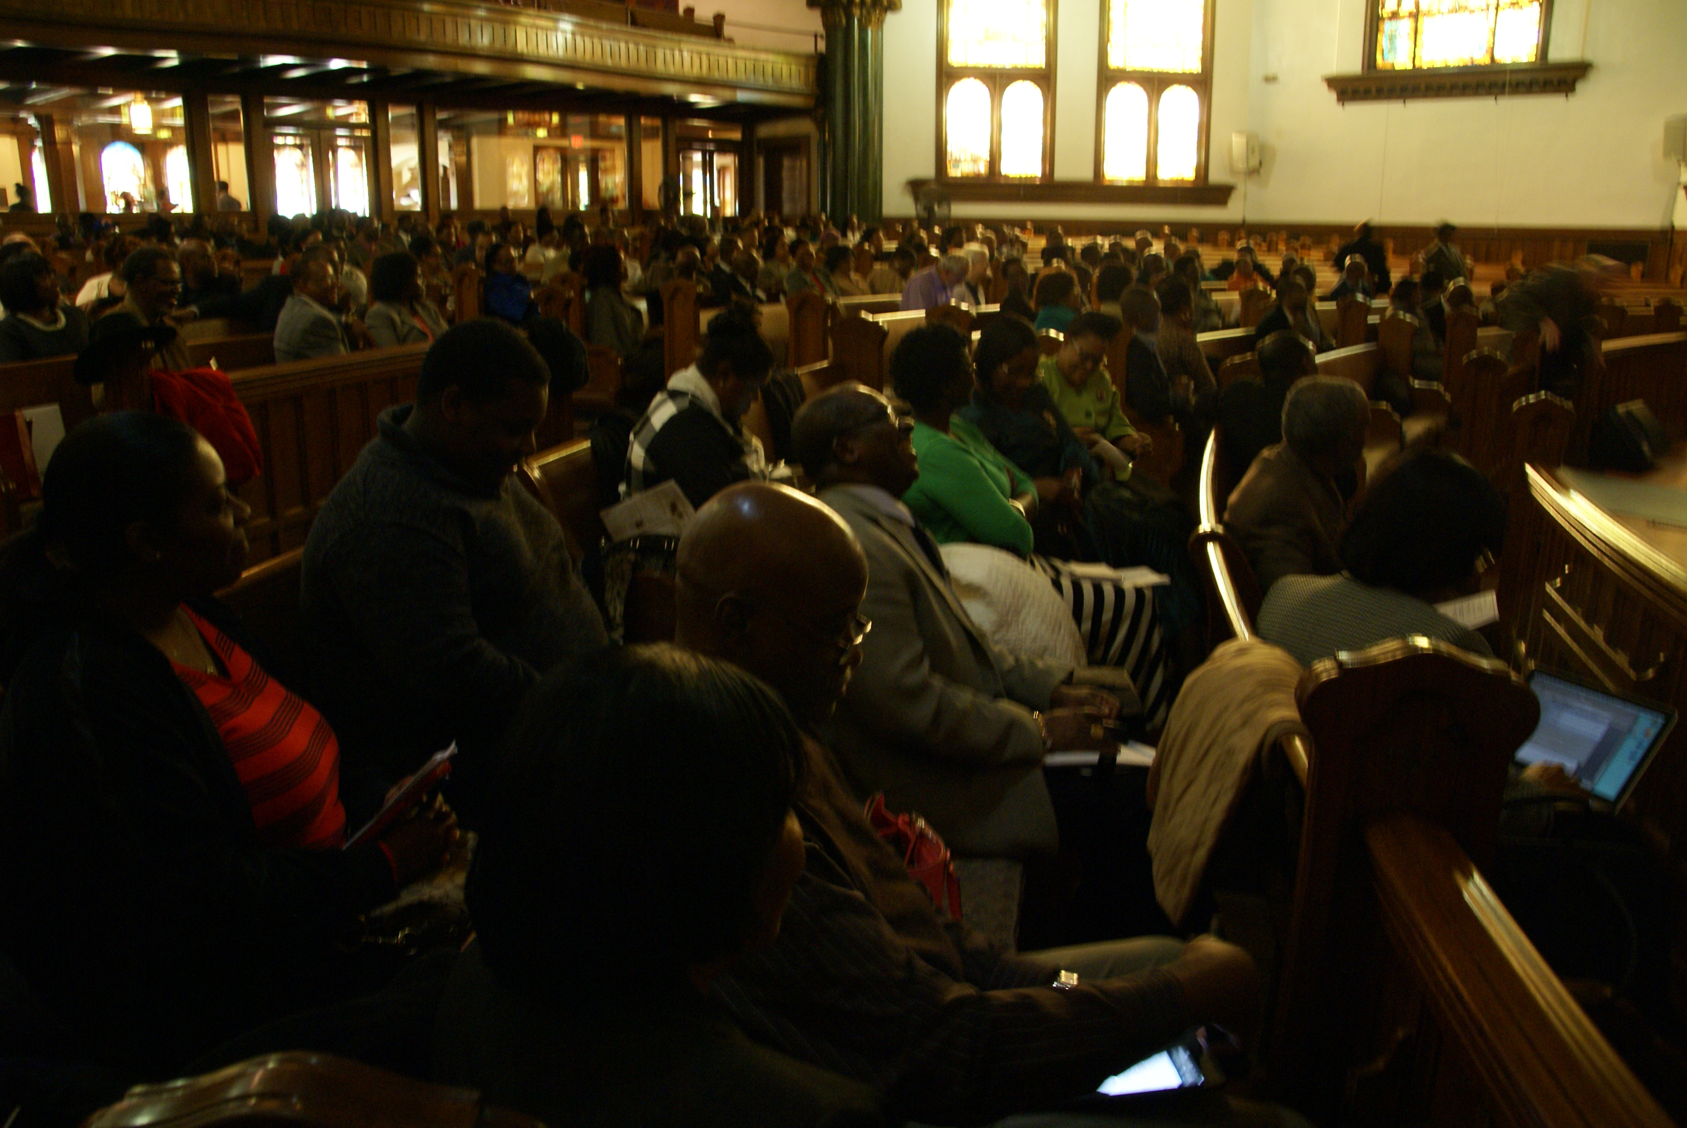
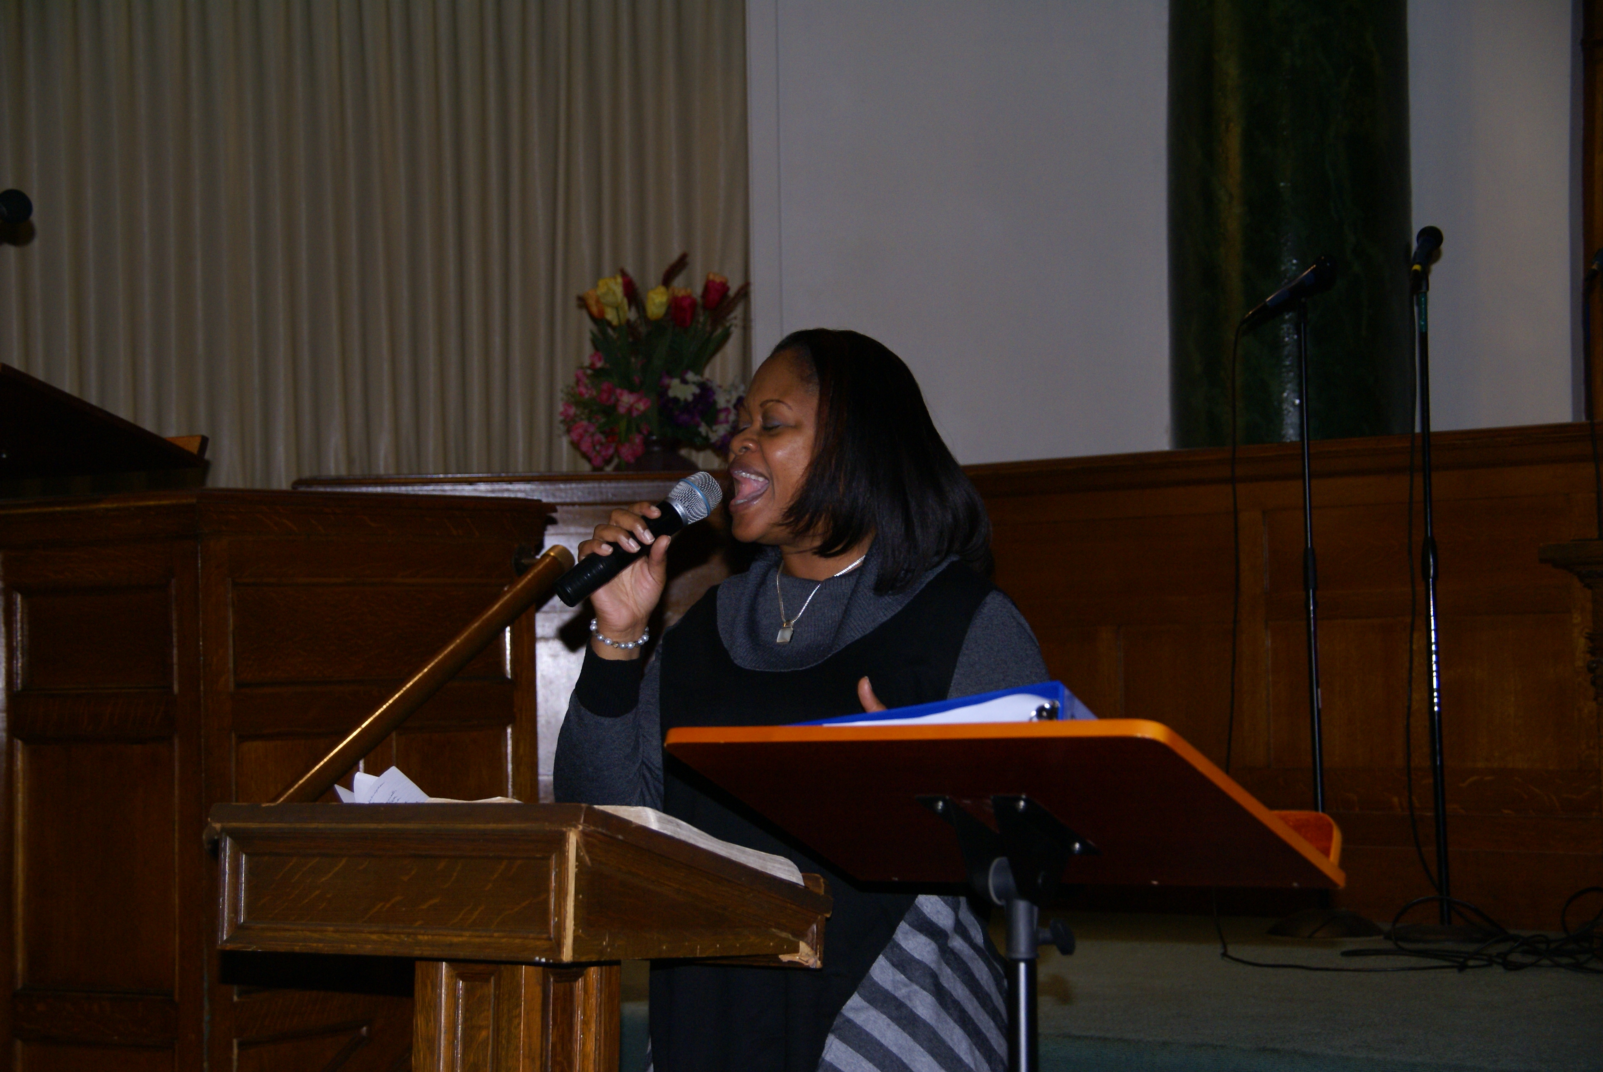

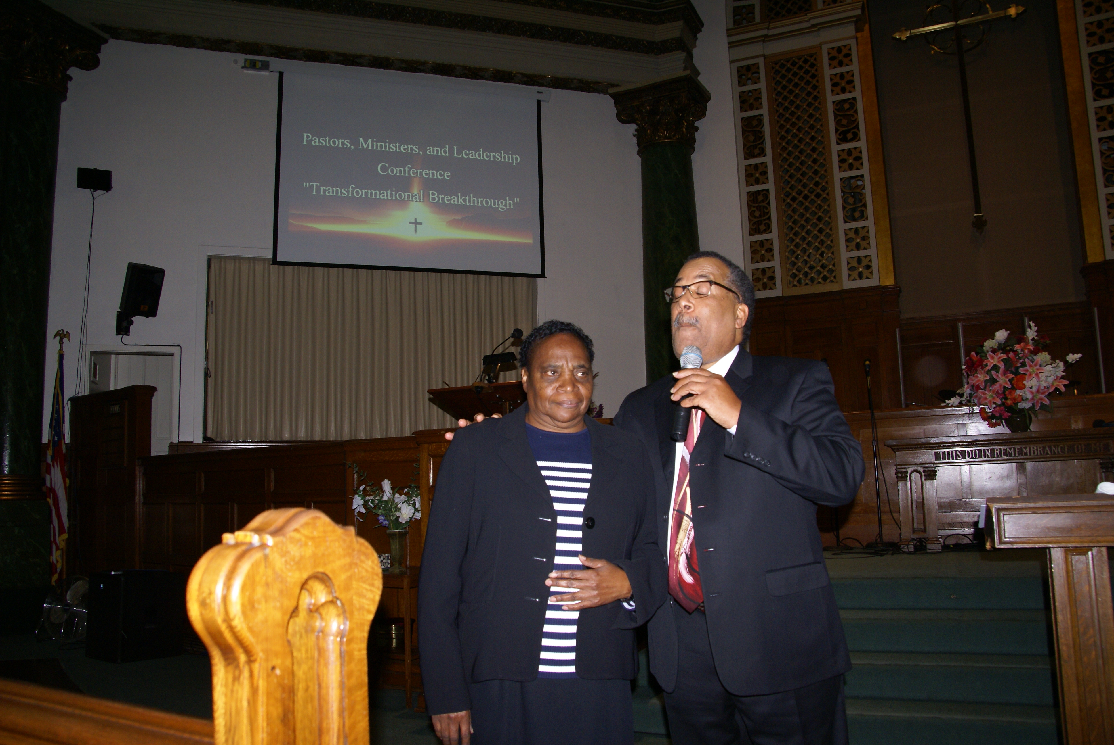

NER Home Mision Fund
We are asking that each member donate $100 towards the Region’s Home Mission Fund. Thank you to all that contributed to this worthy cause! Please forward all pledges to the COGOP, NER Office, P O Box 11652, Albany, NY 12211. Blessings!
Ladies’ Enrichment Weekend 2015
Ladies Enrichment weeknd held at Stamford, CT was absolutely spectacular. Can you imagine over 600 spirit-filled women gathered together in one place, with one purpose in mind, just to glorify and exalt the King of Kings and Lord of Lords. Needless to say “Heaven came down and glory filled their souls.” Throughout the Retreat from beginning to end, there were experiences of supernatural deliverences and mighty moves of God’s presence and power. The truth is many were saved, sanctified, Holy Ghost baptized, healed and there were awe-inspiring testimonies of marriages being restored and homes healed. As waves of God’s power kept breaking through each session the spirit of rejoicing and celebration was indeed taken to another level.
The theme for this awesome Retreat was “Overcomer” repeatedly reminding the ladies of who they are in Christ Jesus, never just victims but victors always by the blood of the lamb and the word of their testimony.
The guest speaker Carnetta Ferguson from the Bahamas was simply amazing. All the other speakers, preachers, teachers, presenters wre mightily used by the Spirit. Minister Lona Beckford powerfully preached the closing message of this weekend feast and must be commended for an outstanding job of planning, organizing and moderating this glorious event. The challenge is to have 1,000 women in next year’s Retreat. With excitement we declare to God to be all the glory!
2nd Place Winners
Jerusalem Avenue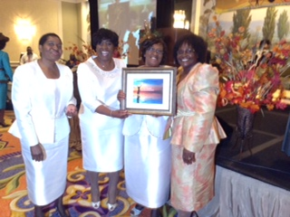
1st Place Winner of most attending Church Avenue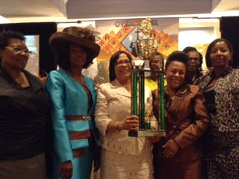

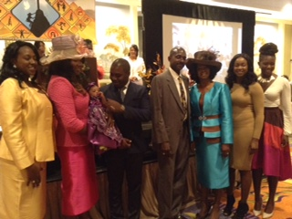

Regional Director Lona Beckford & family

BERMUDA
What a joy it was to be with our precious saints in the beautiful island of Bermuda for the very first time, October 1st – 6th, 2015. What an enchanting island filled with such warm and friendly people, especially the saints!
Unfortunately, our trip there was somewhat interrupted by hurricane Joaquin which, thank God, by the time it got to Bermuda was downgraded to a category 2 and resulted in minimal damage to the island. Joyfully, before the hurricane landed we were blessed to be able to attend church with the saints and have beautiful fellowship and real worship time together.
Let us continue to pray for the work there and for the team that is planning to visit in March 2016 sponsored by the Evangelism Department. It is our plan to be able to plant another church there soon.
Presently, the saints there are in need of financial miracles to help offset monthly mortgage commitments. District Overseer, Bishop Earl McKay and myself plan another trip there soon. Pray for our pastor, Dwayne Simons and the Leadership Team there on this blessed island. Let us remember Bermuda always in our prayers!
