Overseer’s Desk
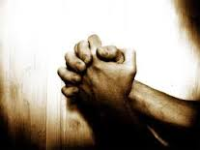

Apocalyptic Praying:
In his most thought-provoking book “The Contemplative Pastor” Eugene Peterson dedicates a chapter on the thought – The Apocalyptic Pastor. He further breaks it down to a section on Apocalyptic Prayer. As he refers to St. John as the apocalyptic pastor, he states “St. John’s pastoral vocation was worked out on his knees! He embraces the act of prayer as pivotal to his work and then shows it as pivotal in everyone’s work.”
He contends, “Nothing a pastor does is different in kind from what all Christians do, but sometimes it is more focused more visible. He strongly reminds his audience that St. John never leaves the place of prayer, he never abandons the practice of prayer. He is most careful to point out that right down to the end of the book he is still praying Amen. Come Lord Jesus! (Rev. 22:20).
As twenty-first century believers, living in these unquestionably apocalyptic times can we afford to be and do any less. We are Apocalyptic leaders engaged in apocalyptic prayer in these remarkable apocalyptic times. Even so, come Lord Jesus! May we seriously pray for revival during this great thanksgiving season!
Leroy Greenaway

We give praise for all the events over the last few months – so in case you missed it - Here are a few highlights!
Family Ministries Back to School Rally
Hosted by Regional Family Ministries on Saturday, September 1st at Bushwick Family Ministries, was according to attendees’ reports an enriched blessing and are thankful for a forum like what was created, and hunger for more. To God be the glory!
Topics covered included:
The importance of family time -
balancing work, ministry and relationships
- Getting back to some of the basics with our family lives in the face of technological advances and competing schedules
- Challenges facing our single brothers and sisters
- Being deliberate in our approach to life, work, school and family
- Understanding our purpose in life
- Pushing past mistakes ...not allowing things that knock us down/bumps along the way to keep us down
- Social media use among teenagers
- Character Matters...the children took time to build their character model that showcased their character traits ... and other topics
It was RAW - REAL - RELEVANT
There were presentations also by the FDNY Safety Unit and Nyack College.
Tanya McLean and Spectrum Drama Ministries added what was just an absolutely rich and emotional ministry through drama.
We were thankful to have well over 100 in attendance given it was a holiday weekend.
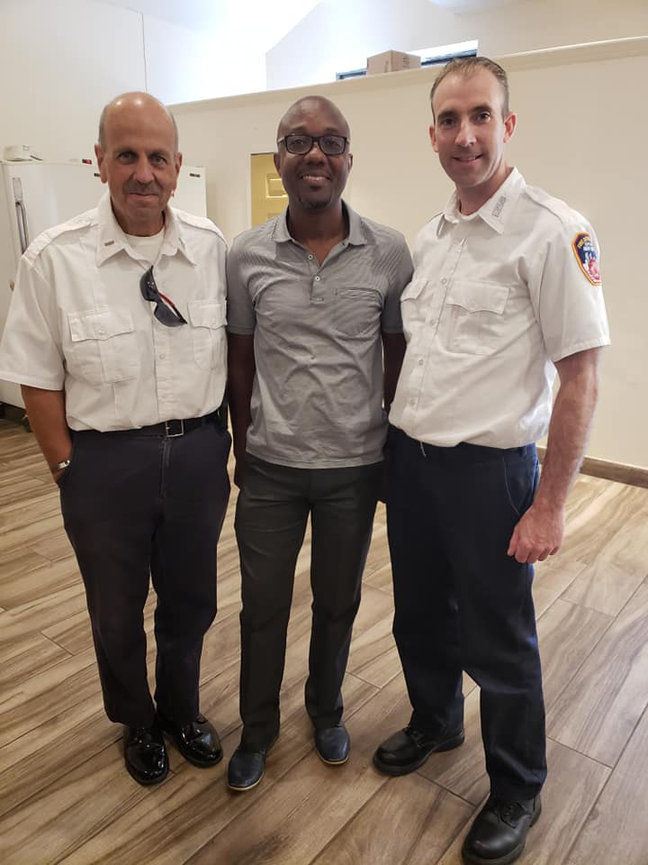

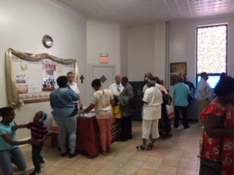

Men Retreat 2018
Was more than a spiritual blast! It was Spirit-filled, fun-filled, power-packed and uplifting! What a time of renewal and refueling for more than 100 men who came together from all across the Northeast Region. The theme this year was Warrior – Mighty through God! On Friday night a powerful message was delivered by Conrad Barnett and on Saturday our guest speaker, Bishop Winston Christian did an outstanding job in breaking the word of life. The sessions were ably moderated by our Regional Men’s director, Herschel Blackwood, who as usual did an amazing job in coordinating and spearheading this event. We look forward to an even greater Men’s Retreat in 2019. Much Praise and thanks also for the two who receive Christ as their personal Savior – to God be the glory!
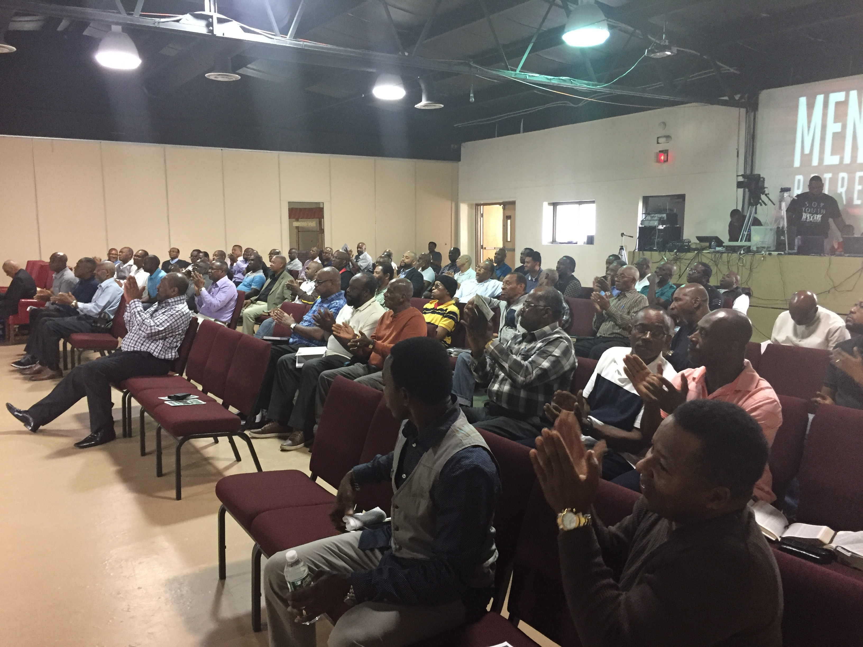
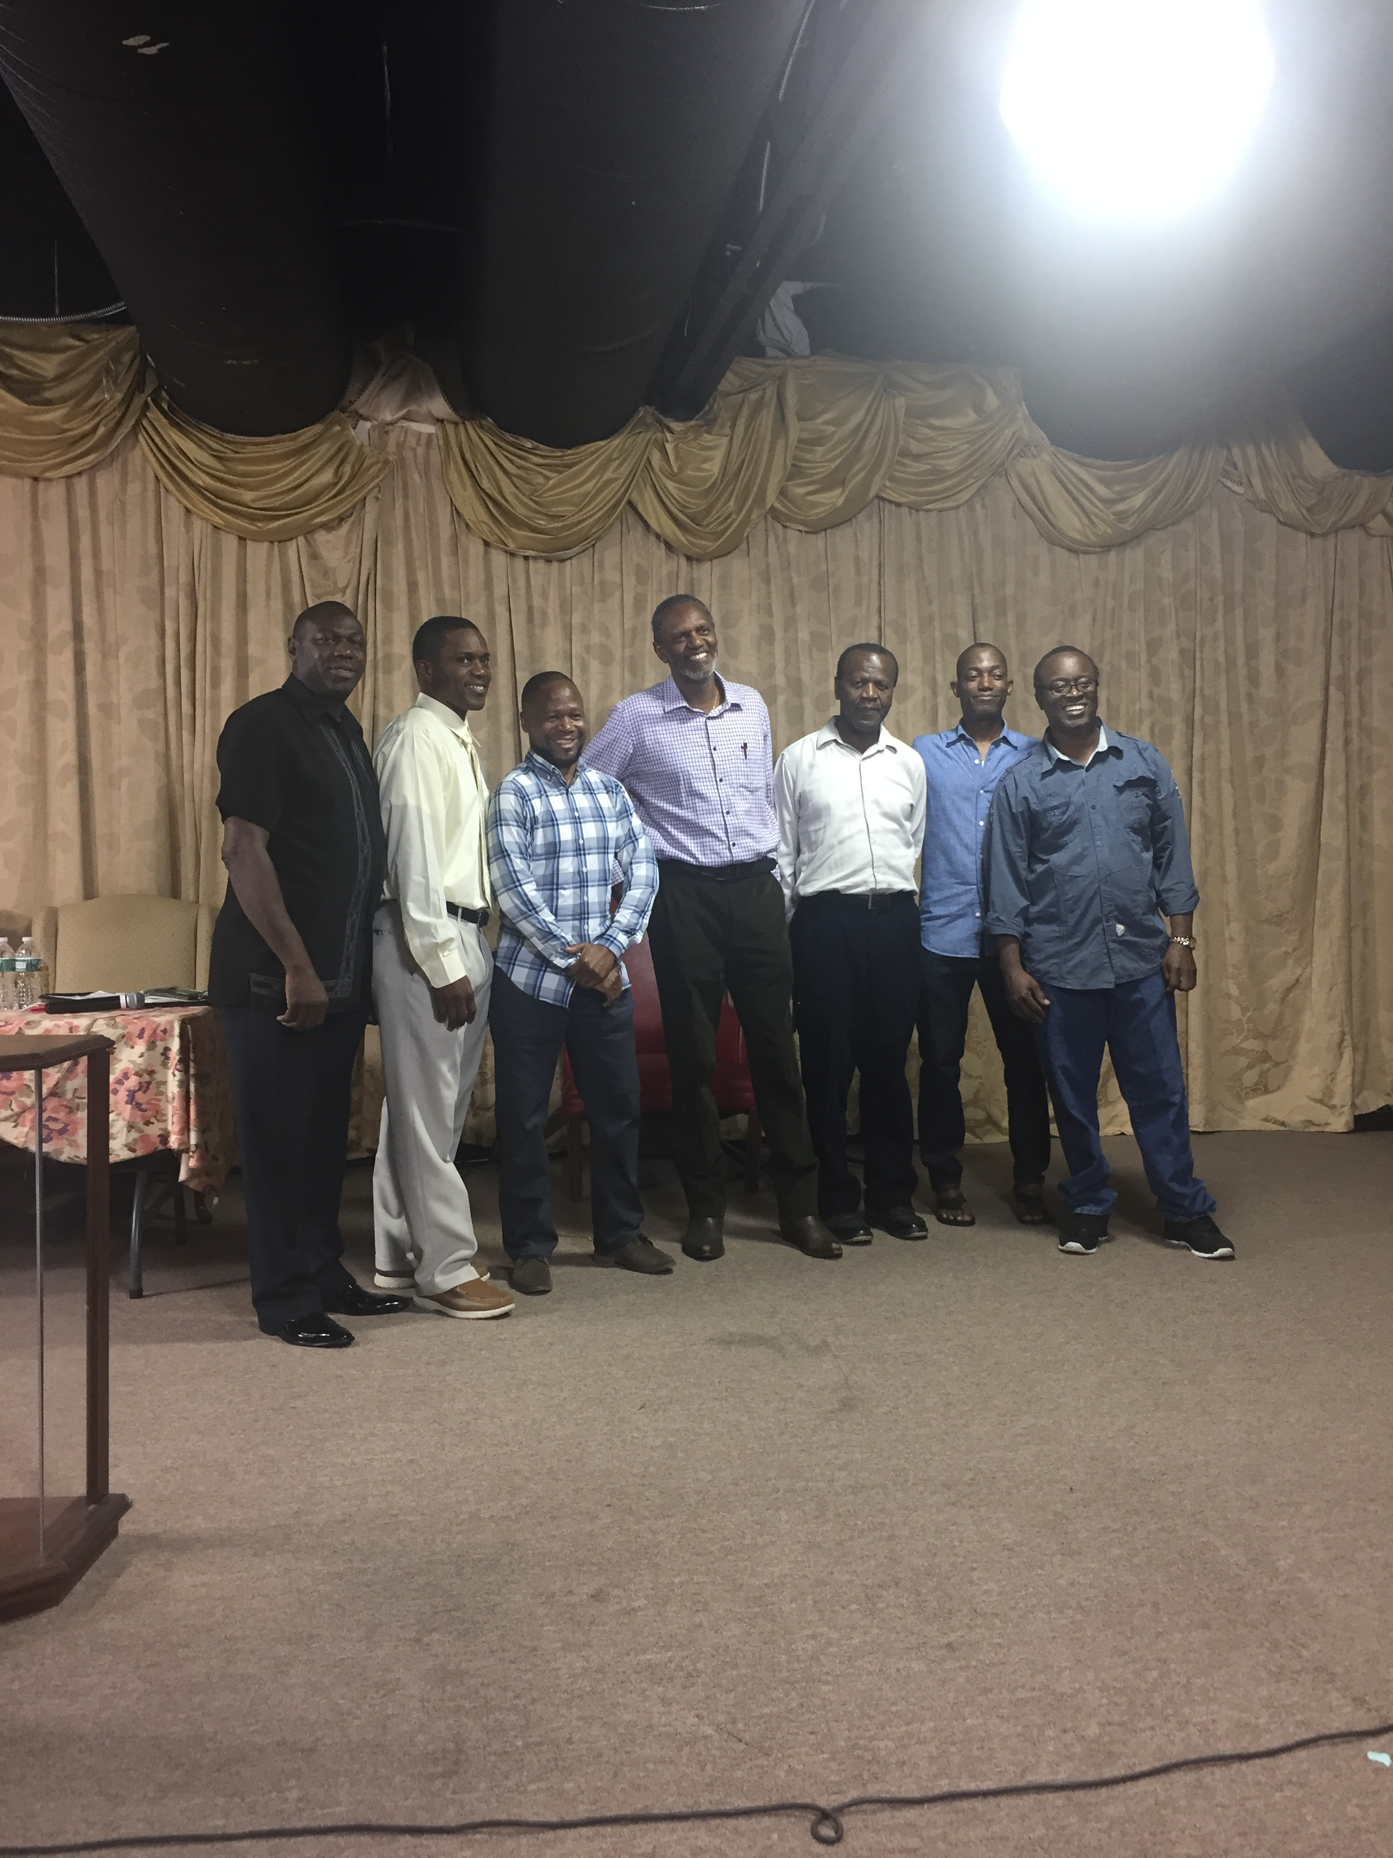

Bronx Tent Crusade 2018
“Jesus Is The Answer!” continues to be the Good News that is being spread throughout the community during our Annual Gospel Outreach. Again, God has given us the opportunity to partake in this amazing ministry under the Tent. Nine years ago, an empty lot, two blocks from the church, at 1020 Carroll Place, became the site of our Tent Crusade. And what an amazing nine years it has been!
This year the Crusade was held August 5-24, 2018, Sunday through Friday evenings from 7:30 pm to 9:00 pm. The average attendance was 110 and during the course of the meetings over 300 people came forward for prayer.
Three dynamic evangelists shared the Word and gave the call to new life in Christ, and the church rejoiced as many souls came forward and answered the call to salvation and deliverance. God moved and 6 gave a confession of Faith. Ten testified of healings and one former member returned to the fold.
God touched many lives, and by the end of the Crusade, there were 6 candidates for baptism.
Thanks to the vision and dedication of our Bishop and the commitment of the leaders and congregation, we thank God for the fruits of this year’s Crusade; we have seven new regular attendees so far as a result of this year’s tent revival. Sister Merleta Bennett, a former drug addict, is one of the standout products of the Tent Crusade. She was baptized and is now a member of our congregation. She was completely delivered from crack cocaine, having been an addict for 27 years, and testified, “I’ll never looked back!”
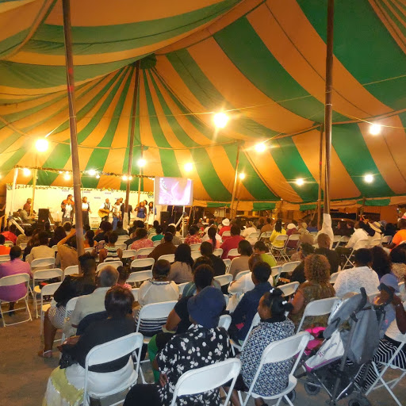
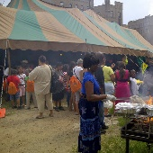
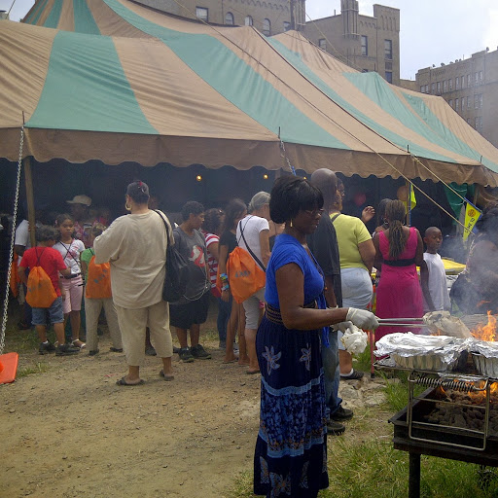
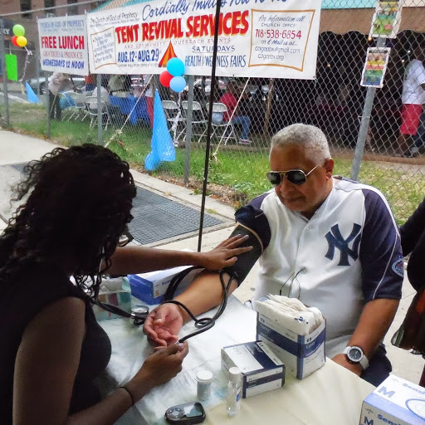

Family Worship Center – Bronx
On September 23, 2018 FWC held their annual community day with lots of giveaways including 200 book bags and back to school supplies. There was also plenty of food and groceries for the community. It was indeed a blessed day and Pastor Ball and saints give God praise that they could in some way be a blessing to their community and show love in tangible ways.
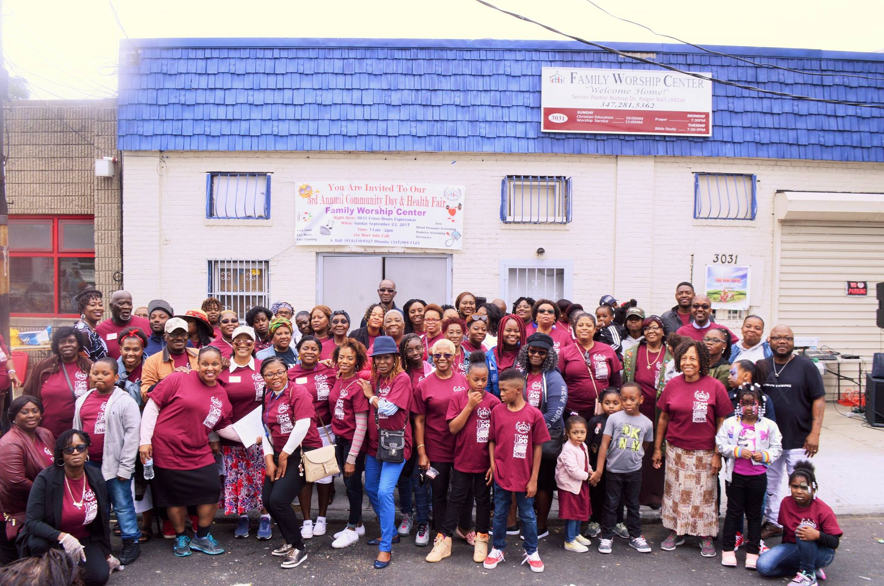

Grace Worship Center
On Saturday, Sept 15th the pastor and members of GWC - Rogers Avenue, teamed up with other denominations and ministers for their annual “Feed the Family” event. What a blessing it was to be able to distribute winter jackets, clothes, food and other items to many from the community. This awesome event included worship and the word ministry. We were able to feed and minister to approximately 200 people. Much thanks to our Outreach leader Sister Joyce Walters and to our Pastor Sean Johnson. To God be the glory as we continue to show that the good news involves not just the salvation of souls, but ministry to the whole person – physical, social, spiritual.

Feeding the Family Event Brooklyn
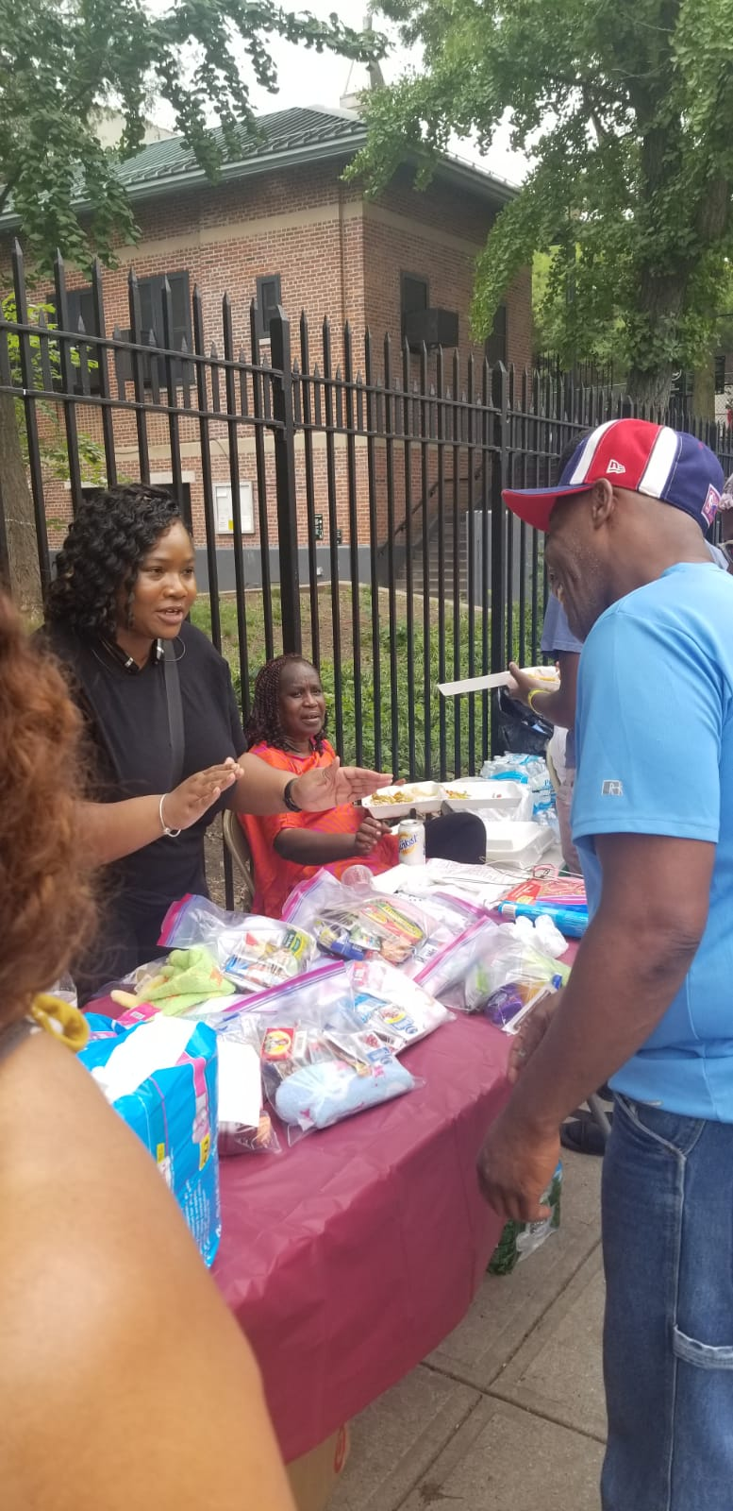
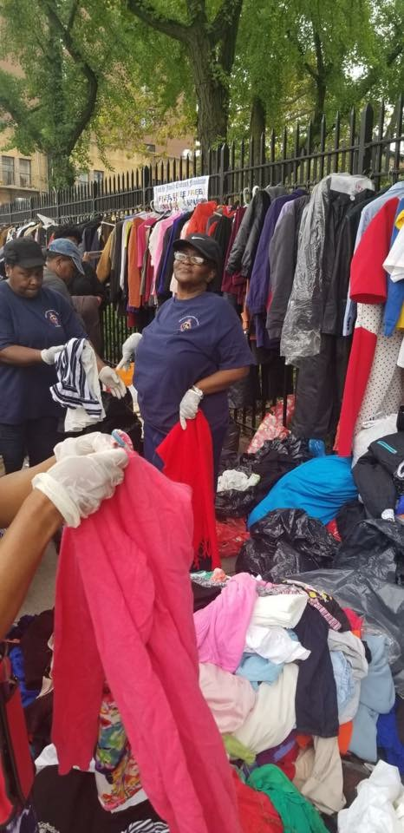

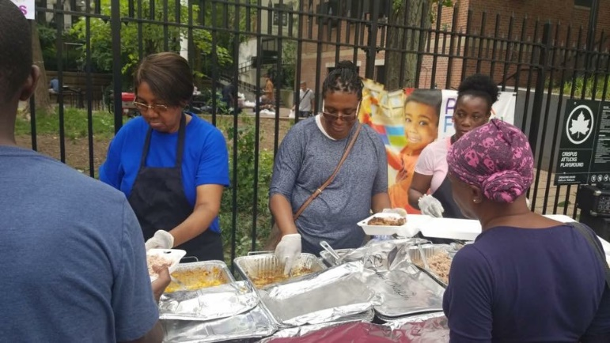
UPCOMING EVENTS
New Appointments
Evangelism Outreach
Brian Blair, Lorna Brown, Darius Hicks, Sharia Hall, Milton Johnson and John Lee, Jr.
Music Director
Racquel Bassier

Youth Camp Team
Glen Jenkins
Joan P. Latty
Viveen Murray

Youth Ministry
Antony E. & Tashna Daley
November 2018
9-11th - Bermuda Ladies’ Conference
10th – 11th - Couples MINI-GET-AWAY WEEKEND
Merry Christmas
& HAPPY NEW YEAR
January 2019
2nd – 22nd - 21 DAYS OF PRAYER
6th – 26th - International Office dates
20th - INTERNATIONAL SIMULCAST
(Sunday evening 7:00 pm)
February
22nd –23rd - Regional Youth Event {to be confirmed}
March
1st – 3rd - Marriage & Couples’ Retreat
9th - CHILDREN’S MINISTRY TRAINING
15th –17th Long Island & Queens District
Convention - Bishop Carlton Chambers
30th - Men’s Day 2019

See www.cogopner.org for more info.

